

[Artificial Intelligence in](https://doi.org/10.1016/j.aiig.2023.04.001) G[eosciences 4 (2023) 59–67](https://doi.org/10.1016/j.aiig.2023.04.001)   
 Contents lists available at ScienceDirect   
Artificial Intelligence in Geosciences

journal homepage: [www.keaipublishing.com/en/journals/artificial-intelligence-in-geoscience](http://www.keaipublishing.com/en/journals/artificial-intelligence-in-geosciences)s

Machine learning elucidates the anatomy of buried carbonate reef from seismic reflection data   
Priyadarshi Chinmoy Kumara,b, Kalachand Saina,b,*   
a *Wadia Institute of Himalayan Geology, 33 GMS Road, Uttarakhand, India*   
b *Seismic Interpretation Laboratory-WIHG, India*

|  |  |
| --- | --- |
| A R T I C L E I N F O | A B S T R A C T |
| *Keywords:*  Carbonate reef  Marine seismic  Seismic attributes  Structure  Machine learning  Offshore  NW Australia | A carbonate build-up or reef is a thick carbonate deposit consisting of mainly skeletal remains of organisms that can be large enough to develop a favourable topography. Delineation of such geologic features provides important input in understanding the basin’s evolution and petroleum prospects. Here, we introduce a new attribute called the Reef Cube (RC) meta-attribute that has been computed by fusing several other seismic at-tributes that are characteristics of the reef through a supervised machine-learning algorithm. The neural learning resulted in a minimum nRMS error of 0.28 and 0.30 and a misclassification percentage of 1.13% and 1.06% for the train and test data sets. The Reef Cube meta-attribute has efficiently captured the anatomy of carbonate reef buried at ~450 m below the seafloor from high-resolution 3D seismic data in the NW shelf of Australia. The novel approach not only picks up the subsurface architecture of the carbonate reef accurately but also accelerates the process of interpretation with a much-reduced intervention of human analysts. This can be efficiently suited for delimiting any subsurface geologic feature from a large volume of surface seismic data. |

**1. Introduction**

A carbonate reef is a thick carbonate deposit displaying an ante-cedent topography relative to the surrounding depositional surface (Heckel, 1974; Burgess et al., 2013). Carbonate reefs are attractive tar-gets for hydrocarbon exploration in frontier and mature sedimentary basins (Burgess et al., 2013; Saqab and Bourget, 2015). Tectonic pro-cesses, eustasy, basinal physiography, and climatic conditions (Zampetti et al., 2004) control their evolution and geometry. They are potential stratigraphic traps and account for half of the global hydrocarbon re-serves (Kusumastuti et al., 2002; Neuhaus et al., 2004; Ehrenberg et al., 2007; Ahr, 2011). The seismic reflection experiment is one of the best possible methods for delineating subsurface carbonate reefs. However, it might be challenging to interpret them accurately as they exhibit fundamental similarities to other geologic features, e.g., buried vol-canoes, erosional remnants, or tilted fault blocks (Burgess et al., 2013; Niyazi et al., 2021).

The processing/modeling of seismic data has made substantial progress over the past decade, significantly improving subsurface im-ages (Burgess et al., 2013; Kumar and Sain, 2018; Kumar et al., 2019; Kumar and Sain, 2020; Sain and Kumar, 2022). Human analysts or

interpreters primarily use seismic attributes to capture the structural geometry and disposition of subsurface features from the derived im-ages. However, interpreters need help to derive accurate information about a specific geologic target. An individual seismic attribute is not uniquely responsive to a particular geologic body and thus cannot distinguish objects of different origins (Kumar and Sain, 2018; Kumar et al., 2019; Kumar and Sain, 2020; Sain and Kumar, 2022; Niyazi et al., 2022). Hence, the impact of an attribute’s geological non-uniqueness and non-completeness keeps changing based on its usage and is entirely interpretation-dependent (Sain and Kumar, 2022).

Here we attempt to provide a unique solution to such a perplexing scenario by designing a new attribute, defined as the Reef Cube (RC) meta-attribute, using a fully connected multi-layer perceptron neural network following the supervised scheme of machine learning that al-lows a machine or intelligent system to learn and get equipped in solving a complex problem for prediction of the desired result. A set of computer-oriented programs are employed on a small portion of data (preferably 20%) during the learning process to accelerate the realistic interpretation of the entire volume of data without extensive human intervention (Kumar and Sain 2018, 2020; Kumar et al., 2019; Sain and Kumar 2022). Since the Browse Basin on the NW shelf off Australia has

* Corresponding author. Wadia Institute of Himalayan Geology, 33 GMS Road, Uttarakhand, India. *E-mail addresses:* [kumarchinmoy@gmail.com](mailto:kumarchinmoy@gmail.com) (P.C. Kumar), [kalachandsain7@gmail.com](mailto:kalachandsain7@gmail.com) (K. Sain).

<https://doi.org/10.1016/j.aiig.2023.04.001>   
[Received 10 January 2023; Received in rev](https://doi.org/10.1016/j.aiig.2023.04.001)ised form 3 April 2023; Accepted 19 April 2023   
Available online 26 April 2023   
2666-5441/© 2023 [The Authors. Publishing services by Elsevier B.V.](http://creativecommons.org/licenses/by-nc-nd/4.0/) on behalf of KeAi Communications Co. Ltd. This is an open access article under the CC BY-NC-ND license (<http://creativecommons.org/licenses/by-nc-nd/4.0/>).

*P.C. Kumar and K. Sain*  *Artificial Intelligence in Geosciences 4 (2023) 59–67*

developed a reef-rimmed carbonate platform during the Miocene period, we have looked into the high-quality 3D seismic data for the delimita-tion of the 3D subsurface architecture of carbonate reefs. First, we computed the seismic attributes that can characterize the carbonate reefs and then amalgamated them into a single hybrid attribute, termed the RC meta-attribute, using a machine learning algorithm. The pres-ence of meta-attribute within the data volume, implying the existence of carbonate deposition, can now elucidate the anatomy of carbonate reef automatically from huge data volume with a much-reduced human intervention.

**2. Tectonic structure of the browse basin**

The Browse Basin is a 140,000 km2 offshore extensional sedimentary basin in Australia’s NW Shelf region. (Fig. 1). The basin resembles a pond-like sedimentary depocentre (Rosleff-Soerensen et al., 2016), bounded by the Scott Plateau on the west and Leveque Shelf and northern Canning Basin to the east (Fig. 1; Struckmeyer et al., 1998). It embraces several half-graben structures that dip landwards and strike parallel to the margin (Struckmeyer et al., 1998). The primary depo-centers of the basin are the Caswell and Barcoo sub-basins, which

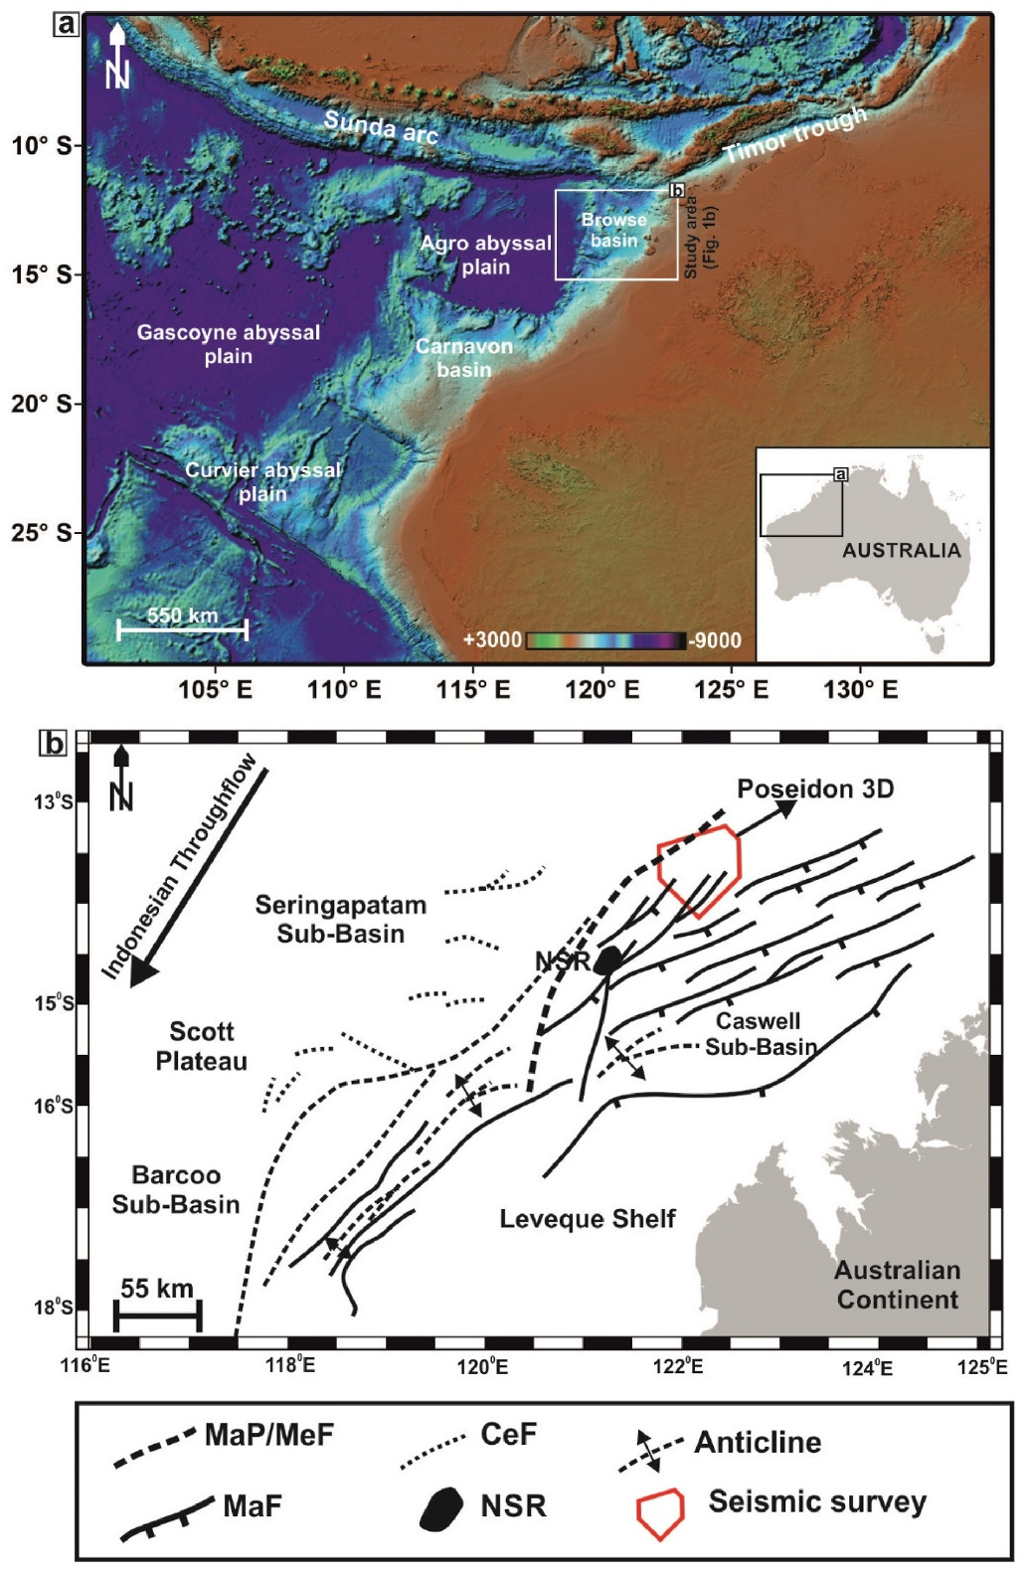

**Fig. 1.** (a) Browse Basin, located in the NW shelf of offshore Australia based on the Gridded Bathymetry Chart of the Oceans (GEBCO); (b) Geo-tectonic map of the Browse Basin showing different structural elements that chiefly strikes northeast. The basin is bounded by the Scott Plateau on the west and Leveque Shelf to the east. The Poseidon 3D seismic survey is shown in red rectangular polygon. MaP/MeF: Major Paleozoic/Mesozoic fault; MaF: Major Fault; CeF: Cenozoic Fault; NSR: North Scott Reef.

60

*P.C. Kumar and K. Sain*  *Artificial Intelligence in Geosciences 4 (2023) 59–67*

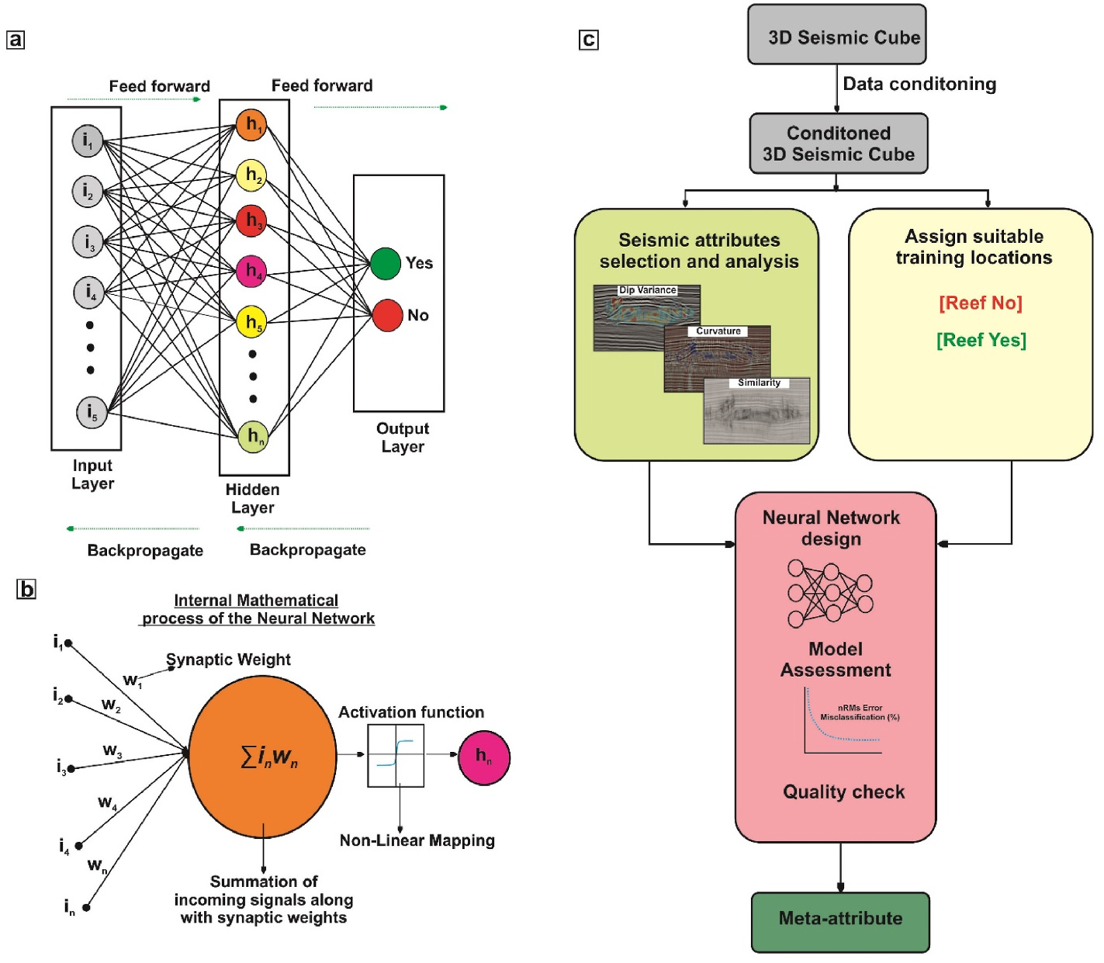

**Fig. 2.** (a, b) Structure and process of Neural Network used in the present research; (c) Proposed workflow for the computation of Reef Cube meta-attribute.

example locations, and (d) Neural Modelling. These steps are elaborated on in succeeding paragraphs.

*3.1. Structural enhancement of 3D seismic data*

Structural conditioning of seismic data maintains the lateral conti-nuity of seismic events and provides enhanced subsurface structural images (Kumar and Sain, 2018; Sain and Kumar, 2022). We have enhanced the 3D seismic cube through a classical dip-steering tech-nique, resulting in a steering cube (or a dip-azimuth volume) (Tingdahl, 1999, 2003; Kumar and Mandal, 2017). The cube contains seismic dip and azimuth information at every sample position. A 3D Fourier Transform-based dip algorithm proposed by Tingdahl (2003) is used to compute the steering cube. The algorithm produces a stable dip-azimuth steering volume. The dip-azimuth is calculated at every sample by transforming a sub-cube of 3 × 3 × 3 samples to the 3D Fourier domain. The maximum dip is estimated with the help of a third-order polynomial curve fitting (Tingdahl, 2003) to the sub-cube around the sample of the highest energy in the Fourier domain. Then a search for the local max-ima is done, and the corresponding dip-azimuth to the local maxima is set as the output. The operation is performed throughout the seismic volume to generate the dip-azimuth volume, called the ’Detailed Steering Cube’ (DSC), and stores detailed structural information. Use of coarser median filtering to the DSC by a filtering step out, i.e., inl: xrl: sample 5 × 5 × 5, results in a steering cube, which is now called the ’Background Steering Cube’ (BSC). It contains the overall dip trends of seismic reflectors and outlines the background structural information. For the present study, the DSC is deemed the best, as the research aims to capture the detailed structural architecture of the geological target.

The DSC is taken as an input for data enhancement through struc-tural filtering (Kumar and Sain, 2018). Structural filtering is performed using a structure-oriented filter (SOF). The key objective of using the SOF is to differentiate between the dip-azimuth of seismic reflectors and overlying noises (Kumar and Sain, 2018; Sain and Kumar, 2022). This

61

*P.C. Kumar and K. Sain*  *Artificial Intelligence in Geosciences 4 (2023) 59–67*

reference time (Table 1), have been chosen to arrest these geophysical signatures. The readers can refer to other works of authors (Kumar and Sain, 2018, 2020; Kumar et al., 2019; Sain and Kumar, 2022) for the definitions and mathematical equations about these attributes.

*3.3. Example locations for training/testing*

The labeled locations are marked arbitrarily along a few **x**lines and inlines. The Reef-yes and Reef-no locations are designated following the seismic signatures and geologic properties described in the previous paragraph. The Reef-yes locations are assigned binary number 1, and Reef-no locations are allocated binary number 0 according to the clas-sification rule of binary numbers. Ambiguous areas where there is no hint of the presence of the target or the areas that are devoid of the target are avoided. About 870 Reef-yes and 880 Reef-no locations are labeled for training and testing. The binary data (0, 1) and seismic attributes at the marked locations are fed into the neural model for training and testing. This entire process is summarized in the following steps.

• In the first step, we randomly examined the seismic lines for the presence of carbonate build-ups.

• In the second step, we further investigated the seismic characteristics of the target over these lines with the help of attribute responses. • Combining the first and second steps, we selected appropriate loca-tions that should be assigned for the network to learn.

• Neural training is then executed over these seismic lines to compute the meta-attribute.

• Once satisfied with the performance of the neural model, the network is made to scan over the entire seismic cube to generate the hybrid attribute, called the Reef Cube (RC) meta-attribute, which is then used to decipher the structural geometry of the buried car-bonate reef.

*3.4. Neural Modelling*

We have designed a fully connected multi-layer perceptron (MLP) network to compute the RC meta-attribute from a suitable suite of seismic attributes to arrest the structural configuration of carbonate build-ups. The MLP consists of three distinct layers: the input, the hid-den, and the output layers, which contain 5, 4, and 2 neurons, respec-tively. The seismic attributes and binary numbers at the picked/labeled locations are fed into the input layer. Neurons receive these data in the hidden layer, where they are grouped and rescaled using a sigmoidal function. This activation function splits the output into binary numbers, i.e., 0s and 1s, where 0 refers to the minimum probability of the car-bonate reef and 1 signifies the maximum likelihood. Only 20% of the

**Table 1**   
Geometrical and seismic characteristics of carbonate reef.

|  |  |  |  |
| --- | --- | --- | --- |
| Name of the Target | Geometry | Seismic Characteristics | Suitable  Seismic  attributes |
| Carbonate Reef | Positive antecedent topography  Localized Thickening | High amplitude  capping reflections High dips at the  marginal ends of the structure  Positive topography leading to convex-up structure  Discontinuity along flank edges  Discontinuous  reflections  Continuous and  parallel reflections | Energy |
| Dip Variance |
| Depositional wings (or on-lap) | Curvature (most  positive)  Similarity/ Coherency Similarity/ Coherency |
| Margin related  faulting  Absence of any  equivalent  overburden structure |
| – |

62

*P.C. Kumar and K. Sain*  *Artificial Intelligence in Geosciences 4 (2023) 59–67*

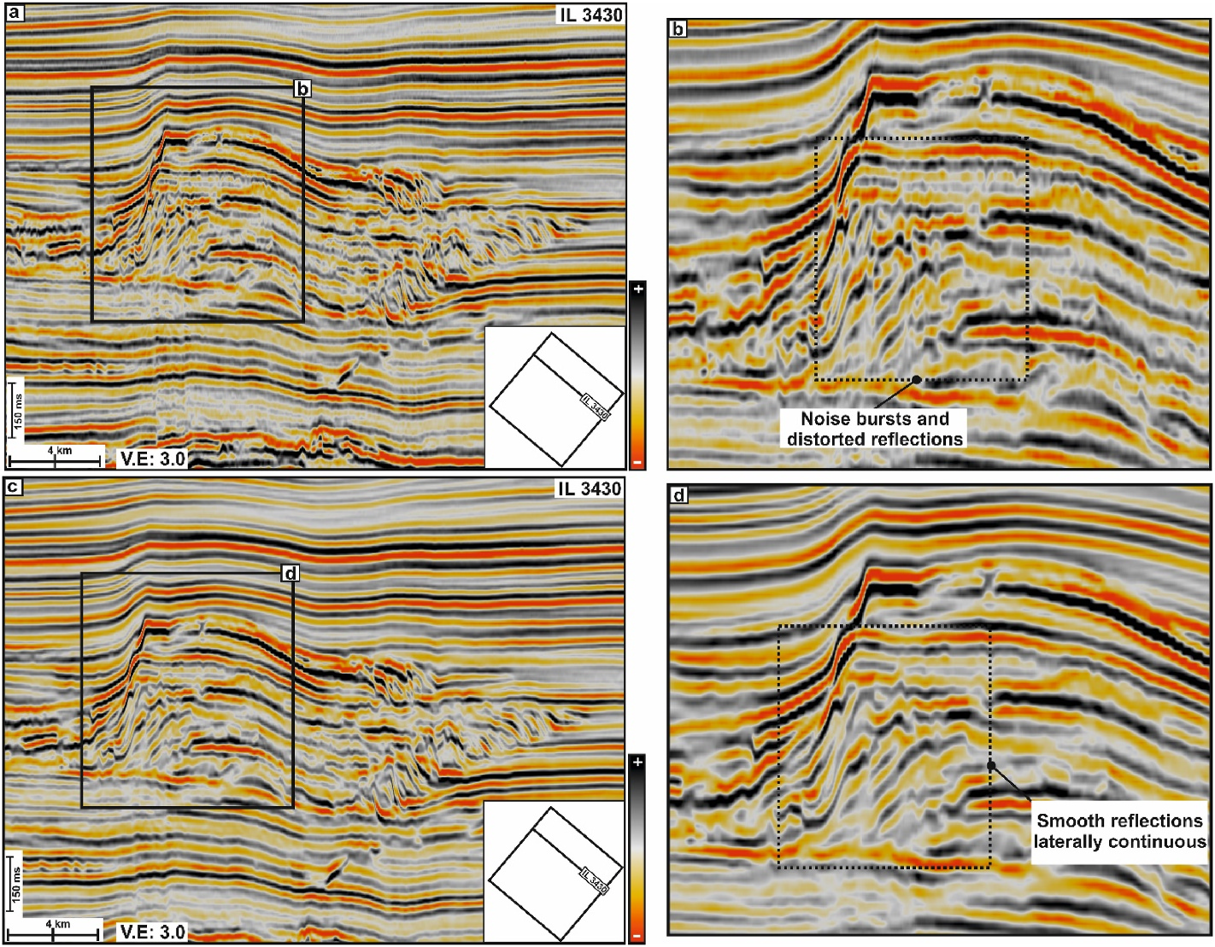

**Fig. 3.** (a) Original time migrated seismic section for IL 3430 from the Poseidon 3D survey; (b) zoomed view of the carbonate-build-up zone marked by black rectangle in (a). Internal reflections within the car-bonate is noisy and are associated with amplitude bursts; (c) Dip Steered Median Filtered (DSMF) time migrated seismic section for the same line IL 3430; (d) zoomed view of carbonate build-up zone marked by black rectangle in (c) showing enhanced seismic reflections free from amplitude bursts within the carbonate build-up.

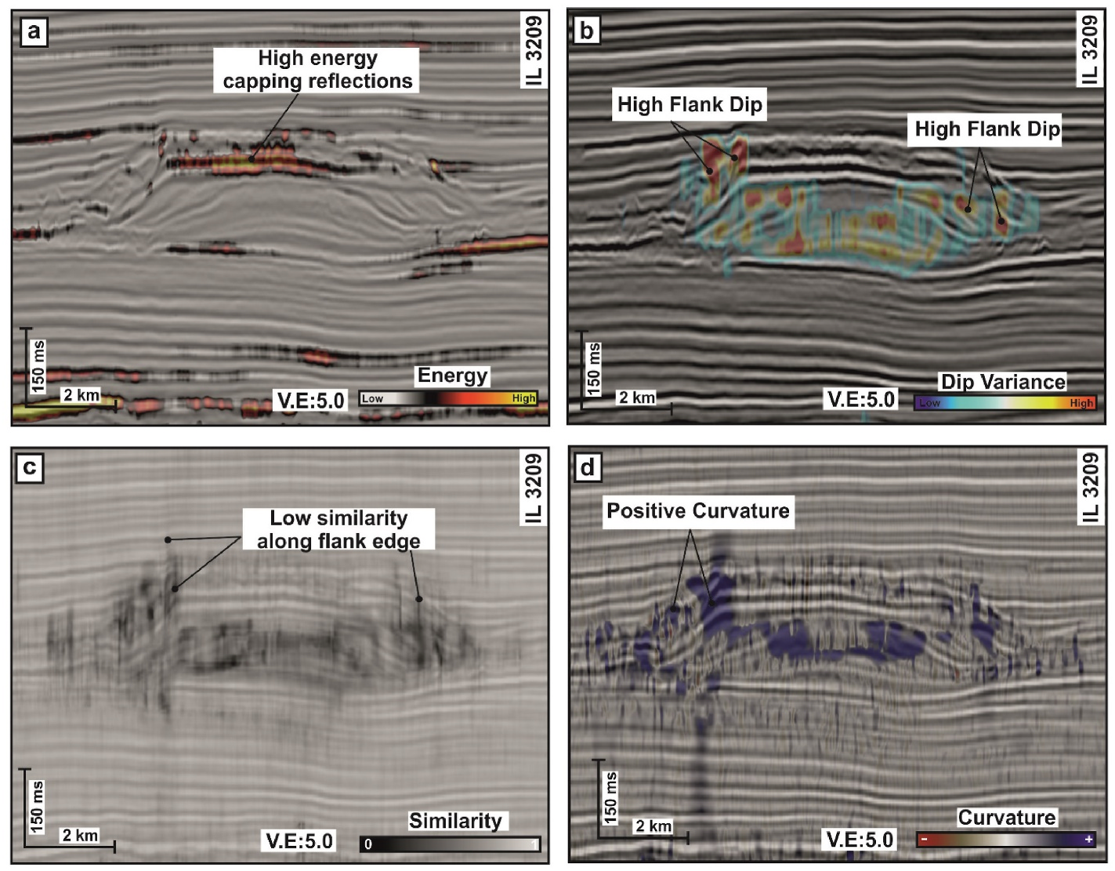

**Fig. 4.** Selected suitable seismic attributes e.g., (a) energy, (b) dip angle variance, (c) similarity and (d) curvature (most positive) attribute demonstrating seismic responses of carbonate build-ups, displayed by co-rendering with the seismic section for line IL 3209.

indicates different growth stages of the build-up. The RC meta-attributes have efficiently captured these phenomena by isolating the build-ups from the surrounding sedimentary successions (Fig. 6b, d, f, and g). The co-rendered view of the amplitude cube and RC meta-attribute have revealed detailed structural geometry of the carbonate build-ups or reef observed over the time map sliced at t = 1168 ms and t = 1244 ms (Fig. 7a–f), respectively. The carbonate reefs consist of several sym-metrical rings stacked upon one another, showing an elbow geometry.

63

*P.C. Kumar and K. Sain*  *Artificial Intelligence in Geosciences 4 (2023) 59–67*

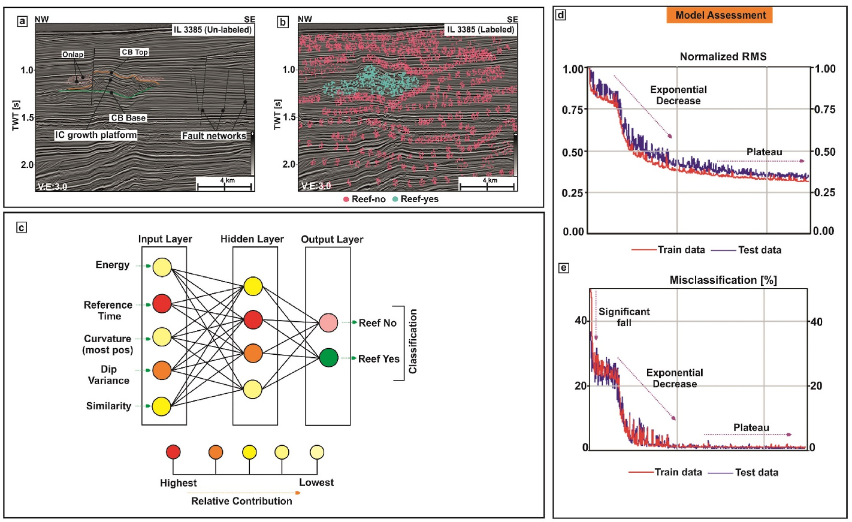

**Fig. 5.** (a–b) Picked example locations: Reef-yes (ice blue dots) and Reef-no (pink dots) demonstrated on a portion of the seismic line IL 3385; (c) A fully con-nected MLP network designed for this study. The color codes showing the relative contribution of nodes during the neural operation (red with the highest contribution and light yellow with the least contribution); (d–e) Performance of the neural model through the normalized RMS (nRMS) and misclassi-fication (%) error curves for train (red curve) and test (blue curve) data sets respectively.

|  |  |  |
| --- | --- | --- |
| **Table 2**  Relative contribution of seismic attributes during training the Neural Model. | | **5. Discussion**  *5.1. Reef Cube as a new interpretation tool for interpreting buried carbonate reefs on seismic refection data* |
| Seismic Attributes | Weights |  |

|  |  |
| --- | --- |
| Energy  Reference Time  Similarity  Dip Variance  Curvature(Most Positive) | 72  98  55  82  57 |

seismic cube. Based on the threshold value of 0.75 for the RC meta- attribute, we could generate the 3D structural anatomy of the buried carbonate build-ups (Fig. 6). The elbow geometry, circular geometry of small reef patches at the crest, and stepped growth platforms are illu-minated automatically. The neural model resembles a "deep-seated cake" structure (Fig. 8) buried ~450 m below the seafloor in the Browse Basin off Australia.

*5.1.1. Effect of structural conditioning of seismic data*   
 Seismic data, when contaminated by coherent or random noise, the S/N ratio decreases and lowers the accuracy of static and dynamic corrections during the processing stage. This finally degrades the quality of the processed seismic cross-sections (Liu et al., 2006; Onajite, 2014). As a result, interpreters struggle to interpret the buried carbonate reefs and their internal anatomy precisely. Advanced data conditioning ap-proaches help to overcome such problems. The initial phase of this research’s workflow aimed at improving the seismic responses of the buried carbonate reefs from reflection seismic data. The original time-migrated 3D seismic data from the Poseidon seismic survey show that the carbonate reef is associated with distorted seismic signals and noisy events (Fig. 3a–b). To circumvent such problems, we have applied a structure-oriented filter called the DSMF to remove the noises that surround and mask the carbonate reef. The filter uses a pre-processed steering cube and a median statistic (i.e., computation of median be-tween the sample values) over seismic amplitudes following the seismic

|  |  |
| --- | --- |
| *IR: Internal Reef*. | **Fig. 6.** (a, c) Seismic section for lines IL 3385 and IL 3269 respectively demonstrating the carbonate build- up with positive antecedent topography. The top and base are marked using thick orange and green line, and the growth stages are indicated by thick blue, pink and red lines; (b, d) Same section co-rendered with the machine generated RC meta-attribute. A color scale with blue-through pale yellow-to red is used to display the meta-attribute, where red defines the highest probability of the carbonate build-up; (e) Seismic section for line IL 3210, not considered for training, showing the presence of carbonate build-up. The seismic line intersects the drilled well Poseidon-1 which penetrates through the SE flank of the study area; (f) Same seismic section for IL 3210 co-rendered with the RC meta-attribute validates the interpreta-tion by efficiently capturing the geometry of the build-up in the study area; (g) Cross sections of seismic lines IL 3210 and XL 2160 co-rendered with the RC meta-attribute shows a perfect match at the intersection, marked by an inverted green triangle. |

64

*P.C. Kumar and K. Sain*  *Artificial Intelligence in Geosciences 4 (2023) 59–67*

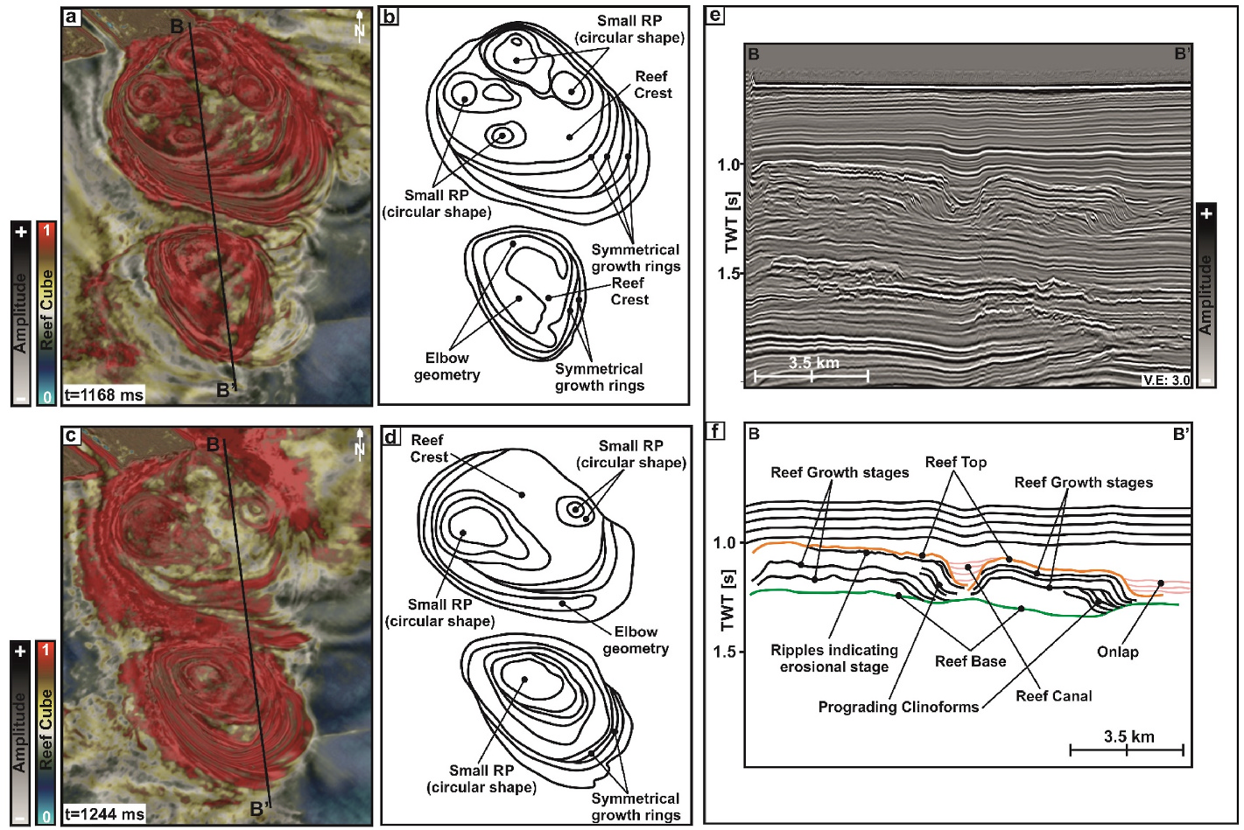

**Fig. 7.** (a, c) Time maps, sliced at t = 1168 ms and t = 1244 ms respectively, by co-rendering the seismic amplitude cube with the RC meta-attribute; (b, d) Line drawings corresponding to the same time maps showing the structural elements of the carbonate build-up; (e, f) Random seismic line BB’ and the corresponding

interpretation. *RP: Reef Patch*.

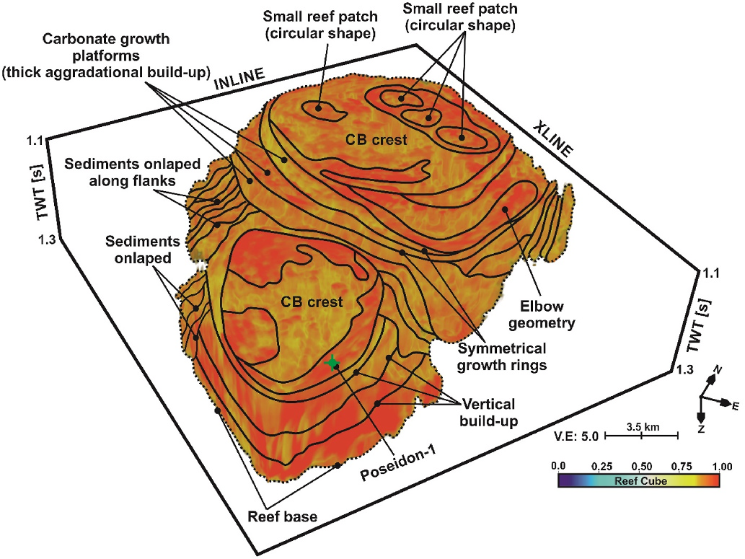

**Fig. 8.** 3D anatomy of the carbonate reef or build-up, as elucidated by the RC meta-attribute. The build-ups demonstrate a “deep seated cake” structural configuration. A pastel color scale is used to display the RC meta-attribute. The small reef patches (dark red color) has high probability of being identified as reef and CB crest and growth platforms (yellow to light red) have the low probability of being a reef. *CB: Carbonate Build-up.*

dips (Sain and Kumar, 2022). The filter effect is tested through different step-outs (e.g., 3 × 3; 5 × 5; 7 × 7). Over-smoothing of the amplitude content is avoided. Thus, applying a mild median filtering step-out (i.e., 3 × 3) to the data volume makes the amplitude content throughout the reef complex (both at the top and internally) laterally continuous, random noise gets suppressed, and the S/N ratio is enhanced. This, in turn, improves the visibility of the carbonate reef (associated with high amplitude content) from the surrounding environment in the condi-tioned seismic volume (see Fig. 3c–d and 6). The seismic conditioning not only preserves the structural architecture of the carbonate reef but also improves the signal quality (S/N) in and around the reef complex.

65

*P.C. Kumar and K. Sain*  *Artificial Intelligence in Geosciences 4 (2023) 59–67*

use of noisy or poor-quality data as input for the computation of the meta-attribute. Using such data may result in feeding inaccurate example locations to the network. As a result, the learning capability of the neural network decreases, and thus the generalization efficiency of the NN fails, making the network to output artifacts. This thus impedes the interpretation. In such instances, the computed meta-attribute may scuffle to deliver a successful interpretation of reef complexes from the data volume.

**6. Conclusions**

This research shows that interpreting subsurface geologic features through an amalgamation of suitable seismic attributes, guided by an interpreter’s acquaintances, results in a hybrid attribute or the so-called meta-attribute (Figs. 4–6). Though an individual attribute captures the seismic response of subsurface geologic structures from the data, a suitable combination improves the images of subsurface targets and reduces interpretation uncertainties. This research’s newly designed RC meta-attribute has efficiently isolated the structural anatomy of buried carbonate reefs or build-ups from the 3D seismic volume (Figs. 6–8). The carbonate build-up delimited through the computation of the RC meta- attribute, resembles a "deep-seated cake" consisting of several vertically stacked platforms, giving rise to an antecedent topography (Fig. 8). Seismic interpreters can employ this neural-based approach to delimit the structural anatomy of carbonate reservoirs from 3D seismic data acquired over sedimentary basins worldwide. Thus, the meta-attribute sets an example for advanced interpretation of seismic data over an individual attribute analysis.

**Data availability**

The data used in this research is publicly available and can be found online. The seismic data and reports are available from Geoscience Australia (<http://www.ga.gov.au/>). Conoco Philips shared this data in the public [domain through the Go](http://www.ga.gov.au/)ogle Drive link ([https://drive.google.](https://drive.google.com/drive/folders/0B7brcf-eGK8CRUhfRW9rSG91bW8?resourcekey=0-NsLk7JL-IDDxUKPVp0dZrw)

[com/drive/folders/0B7brcf-eGK8CRUhfRW9rSG91bW8?resourc](https://drive.google.com/drive/folders/0B7brcf-eGK8CRUhfRW9rSG91bW8?resourcekey=0-NsLk7JL-IDDxUKPVp0dZrw) [ekey=0-NsLk7JL-IDDxUKPVp0dZrw).](https://drive.google.com/drive/folders/0B7brcf-eGK8CRUhfRW9rSG91bW8?resourcekey=0-NsLk7JL-IDDxUKPVp0dZrw)

**Appendix**

*A. Normalized Root Mean Square Error (nRMS)*

**Author contributions**

**P.C.K. (the first author):** Conceptualisation, Data curation and interpretation, Methodology, Investigation, Visualization, Project administration, Writing, Figures-drafting, Review, and Editing, Open-dTect™ Software Resources. **K.S (the second author):** Review and Proofread, Software Resources.

**Funding**

There is no funding associated with this work.

**Declaration of conflict interest**

The authors declare that they have no known competing financial interests or personal relationships that could have appeared to influence the work reported in this paper.

**Acknowledgements**

Director, WIHG, Dehradun, is grateful for permission to publish this work. The authors acknowledge GeoScience Australia for making the seismic data and petroleum reports publicly available under this research’s Creative Commons Attribution 3.0 Australia (CC BY 3.0 AU) license. dGB Earth Sciences is duly acknowledged for providing software support (OpendTect™ v5.0 & v6.0) for this work. Halliburton™ is thanked for providing the DSG interpretation suite. Geosoftware™ is thanked for providing academic licence of Hampson Russell 13.0 and Jason 12.0 for this research. The authors are thankful to the anonymous reviewers, and the Editor-in-Chief Gabriele Morra for the comments and valuable suggestions on earlier version of this manuscript. GEBCO Compilation Group (2019) is thanked for making gridded bathymetry files freely available for academic research. KS acknowledges DST-SERB for according him with JC Bose National Fellowship. This is a Wadia contribution no. WIHG/0274.

|  |  |  |  |  |  |  |  |  |  |
| --- | --- | --- | --- | --- | --- | --- | --- | --- | --- |
| The nRMS error is computed from the RMS error (Eq. A.1) between the targeted (*ti*) and computed (*ci*) values for *i* ranging from 1 to n, which is given as (Eq. A.2) (Kumar and Sain, 2018): | | | | | | | | | |
| *RMS* = | √̅̅̅ | *n* ∑ | (*ti* − *ci*)2 | | | | | (A.1) | |
| *normalized RMS* = *RMS* | | | | / | √̅̅̅ | *n* ∑ | (*ti* − *mean*)2 | | (A.2) |

where the mean is given as in Eq. A.3:

*n*   
*mean* =1∑*ti*  (A.3)

The nRMS error curve demonstrates the overall error on the train and test data sets, with a scale ranging from 0 to 1, where 0 corresponds to no error, and 1 corresponds to the highest error. It has been demonstrated that the lower the nRMS, the better the neural outcome is (Kumar and Sain, 2018, 2020; Kumar et al., 2019; Sain and Kumar, 2022). The other benefit is that error performance can be observed from a single graph display.

*B. Misclassification percentage (%)*

The misclassification percentage is a quality control parameter to understand the wrong predictions made during the classification. To have control over this accuracy, creating a truly representative distribution of the observations for each class (i.e., target and non-target zones) is good enough. The

66

*P.C. Kumar and K. Sain*  *Artificial Intelligence in Geosciences 4 (2023) 59–67*

classification percentage (Eq. B.1) is the ratio of correct predictions to the total number of predictions.

*Classification* (%) =*Number of correct predictions ~~Total numebr of predictions~~ x* 100 (B.1)

The misclassification percentage (Eq. B.2) is defined as the ratio of wrong predictions to the total number of predictions.

*Misclassification* (%) =*Number of wrong predictions ~~Total numebr of predictions~~ x* 100 (B.2)

**References**

[Ahr, W.M., 2011. Geology of Carbonate Reservoirs: the Identification, Description an](http://refhub.elsevier.com/S2666-5441(23)00020-5/sref1)d [Characterization of Hydrocarbon Reservoirs in Carbonate Rocks. John Wiley & Sons](http://refhub.elsevier.com/S2666-5441(23)00020-5/sref1). [Barn](http://refhub.elsevier.com/S2666-5441(23)00020-5/sref2)[es, A.E., 2016. Handbook of Post-stack Seismic Attributes, SEG, Tusla.](http://refhub.elsevier.com/S2666-5441(23)00020-5/sref1)

[Burgess, P.M., Winefield, P., Minzoni, M., Elders, C., 2013. Methods for id](http://refhub.elsevier.com/S2666-5441(23)00020-5/sref2)[entification o](http://refhub.elsevier.com/S2666-5441(23)00020-5/sref3)f [isolated carbonate buildups from seismic reflection dataIdentification of Isolated Carbonate Buildups from Seismic Reflection Data. AAPG Bull. 97 (7), 107](http://refhub.elsevier.com/S2666-5441(23)00020-5/sref3)1[–1098](http://refhub.elsevier.com/S2666-5441(23)00020-5/sref3).

[Cho](http://refhub.elsevier.com/S2666-5441(23)00020-5/sref4)[pra, S., Marfurt, K.J., 2007. Seismic Attributes for Prospect Identification and](http://refhub.elsevier.com/S2666-5441(23)00020-5/sref3) [Reservoir Characterization. SEG, Tusla.](http://refhub.elsevier.com/S2666-5441(23)00020-5/sref4)

Con[ocoPhillips, 2012. Poseidon 3D Marine](http://refhub.elsevier.com/S2666-5441(23)00020-5/sref4) Surface Seismic Survey Interpretation Report (unpublished). [https://drive.google.com/drive/folders/0B7brcf-eGK8Cbk9ueH](https://drive.google.com/drive/folders/0B7brcf-eGK8Cbk9ueHA0QUU4Zjg) [A0QUU4Zjg](https://drive.google.com/drive/folders/0B7brcf-eGK8Cbk9ueHA0QUU4Zjg).

[De G](http://refhub.elsevier.com/S2666-5441(23)00020-5/sref6)[root, P., Lig](https://drive.google.com/drive/folders/0B7brcf-eGK8Cbk9ueHA0QUU4Zjg)[tenberg, H., Oldenziel, T., Connolly, D., Meldahl, P., 2004. Examples of](http://refhub.elsevier.com/S2666-5441(23)00020-5/sref6) [multi-attribute, neural network-based seismic object detection. Geological Society](http://refhub.elsevier.com/S2666-5441(23)00020-5/sref6) [29 (1), 335–338. London, Memoirs.](http://refhub.elsevier.com/S2666-5441(23)00020-5/sref6)

[Dixit, A., Mandal, A., 2020. Detection of gas chimney and its linkage with deep-seated](http://refhub.elsevier.com/S2666-5441(23)00020-5/sref7) [reservoir in Poseidon, NW shelf, Australia from 3D seismic data using multi-attribute](http://refhub.elsevier.com/S2666-5441(23)00020-5/sref7) [analysis and artificial neural network approach. J. Nat. Gas Sci. Eng. 83, 10358](http://refhub.elsevier.com/S2666-5441(23)00020-5/sref7)6[.](http://refhub.elsevier.com/S2666-5441(23)00020-5/sref7) [Ehre](http://refhub.elsevier.com/S2666-5441(23)00020-5/sref8)[nberg, S.N., Nadeau, P.H., Aqrawi, A.A.M., 2007. A comparison of Khuff and Ar](http://refhub.elsevier.com/S2666-5441(23)00020-5/sref7)[ab](http://refhub.elsevier.com/S2666-5441(23)00020-5/sref8) [reservoir potential throughout the Middle East. AAPG Bull. 91 (3), 275–286.](http://refhub.elsevier.com/S2666-5441(23)00020-5/sref8)

Hec[kel, P.H., 1974. Carbonate Build-Ups in the Geologic Record: a Review.](http://refhub.elsevier.com/S2666-5441(23)00020-5/sref8) [https://doi.](https://doi.org/10.2110/pec.74.18.0090) [org/10.2110/pec.74.18.0090](https://doi.org/10.2110/pec.74.18.0090).

[H¨oc](http://refhub.elsevier.com/S2666-5441(23)00020-5/sref11)[ker, C., Fehmers, G., 2002. F](https://doi.org/10.2110/pec.74.18.0090)[ast structural interpretation with structure-oriented](http://refhub.elsevier.com/S2666-5441(23)00020-5/sref11) [filtering. Lead. Edge 21 (3), 23](http://refhub.elsevier.com/S2666-5441(23)00020-5/sref11)8[–243.](http://refhub.elsevier.com/S2666-5441(23)00020-5/sref11)

[Kaik](http://refhub.elsevier.com/S2666-5441(23)00020-5/sref12)[o, A.R., Tait, A.M., 2001. Post-rift tec](http://refhub.elsevier.com/S2666-5441(23)00020-5/sref11)[tonic subsidence and paleo-water depth in the](http://refhub.elsevier.com/S2666-5441(23)00020-5/sref12) [northern Carnarvon basin, western Australia. APPEA J 41, 367–380.](http://refhub.elsevier.com/S2666-5441(23)00020-5/sref12)

[Kumar, P.C., Mandal, A., 2017. Enhancement of fault interpretation using multi-attribute](http://refhub.elsevier.com/S2666-5441(23)00020-5/sref13) [analysis and artificial neural network (ANN) approach: a case study from Taranak](http://refhub.elsevier.com/S2666-5441(23)00020-5/sref13)i [Basin, New Zealand. Explor. Geophys. 49 (3), 409–424.](http://refhub.elsevier.com/S2666-5441(23)00020-5/sref13)

[Kum](http://refhub.elsevier.com/S2666-5441(23)00020-5/sref14)[ar, P.C., Sain, K., 2018. Attribute amalgamation-aiding](http://refhub.elsevier.com/S2666-5441(23)00020-5/sref13) [interpretation of faults from](http://refhub.elsevier.com/S2666-5441(23)00020-5/sref14) [seismic data: an example from Waitara 3D prospect in Taranaki basin off New](http://refhub.elsevier.com/S2666-5441(23)00020-5/sref14) [Zealand. J. Appl. Geophys. 159, 52–68, 2018.](http://refhub.elsevier.com/S2666-5441(23)00020-5/sref14)

[Kum](http://refhub.elsevier.com/S2666-5441(23)00020-5/sref15)[ar, P.C., Sain, K., 2020. A machine learning to](http://refhub.elsevier.com/S2666-5441(23)00020-5/sref14)[ol for interpretation of Mass Transport](http://refhub.elsevier.com/S2666-5441(23)00020-5/sref15) [Deposits from seismic data. Nature Scientific Reports 10 (1),](http://refhub.elsevier.com/S2666-5441(23)00020-5/sref15) 1[–10.](http://refhub.elsevier.com/S2666-5441(23)00020-5/sref15)

[Kumar, P.C., Omosanya, K.O., Alves, T., Sain, K., 2019. A neural network approach for](http://refhub.elsevier.com/S2666-5441(23)00020-5/sref16) [elucidating fluid leakage along hard-linked normal faults. Mar. Petrol. Geol. 110,](http://refhub.elsevier.com/S2666-5441(23)00020-5/sref16) [518–538.](http://refhub.elsevier.com/S2666-5441(23)00020-5/sref16)

[Kusumastuti, A., Van Rensbergen, P.V., Warren, J.K., 2002. Seismic sequence analysis](http://refhub.elsevier.com/S2666-5441(23)00020-5/sref17) [and reservoir potential of drowned Miocene carbonate platforms in the Madura](http://refhub.elsevier.com/S2666-5441(23)00020-5/sref17) [Strait, East Java, Indonesia. AAPG Bull. 86 (2), 213–232.](http://refhub.elsevier.com/S2666-5441(23)00020-5/sref17)

[Lan](http://refhub.elsevier.com/S2666-5441(23)00020-5/sref18)[ghi, L., Borel, G.D., 2007. Reverse structures in accommo](http://refhub.elsevier.com/S2666-5441(23)00020-5/sref17)[dation zone and early](http://refhub.elsevier.com/S2666-5441(23)00020-5/sref18) [compartmentalization of extension system, Laminaria High (NW shelf, Australia).](http://refhub.elsevier.com/S2666-5441(23)00020-5/sref18) [Mar. Petrol. Geol. 25, 791–803, 2007.](http://refhub.elsevier.com/S2666-5441(23)00020-5/sref18)

[Liu,](http://refhub.elsevier.com/S2666-5441(23)00020-5/sref19) [C., Liu, Y., Yang, B., Wang, D., Sun, J.,](http://refhub.elsevier.com/S2666-5441(23)00020-5/sref18) [2006. A 2D multistage median filter to reduc](http://refhub.elsevier.com/S2666-5441(23)00020-5/sref19)e [random seismic noise. Geophysics 71 (5), V105–V110.](http://refhub.elsevier.com/S2666-5441(23)00020-5/sref19)

[Mel](http://refhub.elsevier.com/S2666-5441(23)00020-5/sref20)[dahl, P., Najjar, N., Oldenziel-Dijkstra, T., Ligtenberg,](http://refhub.elsevier.com/S2666-5441(23)00020-5/sref19) [H., 2002. Semi-automated](http://refhub.elsevier.com/S2666-5441(23)00020-5/sref20) [detection of 4D anomalies. In: In64th EAGE Conference & Exhibition. EAGE](http://refhub.elsevier.com/S2666-5441(23)00020-5/sref20) [Publications BV cp-5).](http://refhub.elsevier.com/S2666-5441(23)00020-5/sref20)

67